6/13/2022

Submitted To

Mam Sadia Zar

PROJECT REPORT

PRISON RECORD MANAGEMENT

**COURSE**

Database System CS-400

**DEGREE & SEMESTER**

BSCS 2ND

**PROJECT TITLE**

Prison Record Management

**SUBMITTED BY**

Muhammad Qasim (21-Arid-632)

Abdul Hadi Mir (21-Arid-564)

Hassan Muneer (21-Arid-620)

Daman Ali (21-Arid-534)

**SUBMISSION DATE**

13/June/2022

**Table Of Contents**

1. Introduction 3
2. Working and Accessibility 3
3. Conceptual Design 4
4. Reduction To Relational Schema 5
5. Normalized Form 6
6. Implementation 7

**Introduction**

A database needed to be design for the storing data of a prison, that includes the complete record of prisoner, officers, and guards. The database should contain the details of the crimes, the prisoner commits, also the details of wings as they are related to prisoner data, officer as well as guards. The database should be able to display results by entering criminal number or his/her name, it may display all his personal details, his wing and his crime details. Similarly, it should be for officer, on entering his name or batch id, one could get, his job details, personal details as well as FIRs, he entered and the detail of the wing he is running.

There would be tables as, Prisoner, FIR, Officer, Guard, Crime, Wing and a table crime_by_prisoner that is due to the many to many relationship between prisoner and crime.

Diving into the details, Prisoner can accommodate his name, a unique id no, age, gender (to separate males and females), address, crime (that can be multiple), and the wing that he has been allotted. For Officer, there would be his name, unique id, address, age, joining details, wing he is controlling, and his salary and rank. Guards should also be saved with one’s name, unique id, age, salary, wing he is guarding and his address. For wing, there would be details of its no, name, in-charge officer, number of prisoners and guards.

**Features & Accesibility**

The system is able to :

1. Save the records
2. Search the specific record
3. Store related data in a separate table
4. Modify the Entered records for the prisoner or an officer or a guard on the change of its duty
5. Delete the Records of a prisoner on leaving

**Conceptual Design**

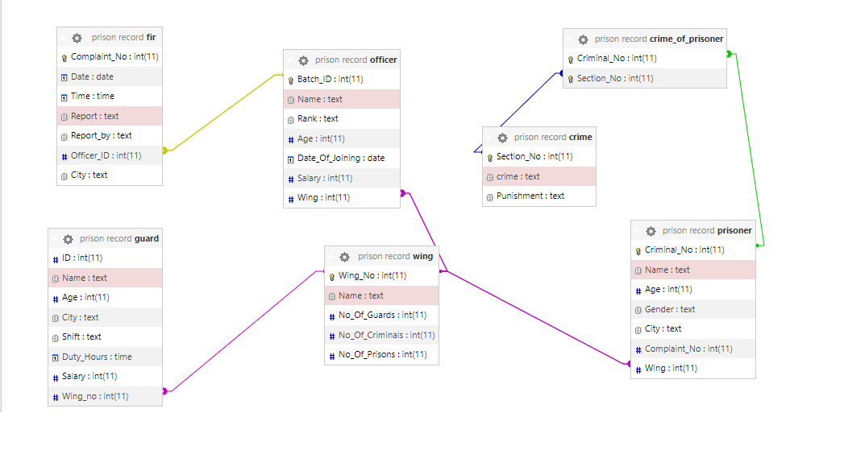

**Relation Schema**

Prisoner

|  |  |  |  |  |  |  |
| --- | --- | --- | --- | --- | --- | --- |
| Criminal_No | Name | Age | Gender | City | Complaint_No | Wing |

Foreign Key Complaint_No Reference Fir(complaint_no)

Foreign Key Wing Reference Wing(Wing_No)

Wing

|  |  |  |  |  |
| --- | --- | --- | --- | --- |
| Wing_No | Name | No_Of_Guard | No_Of_Prison | No_Of_Criminal |

Fir

|  |  |  |  |  |  |  |
| --- | --- | --- | --- | --- | --- | --- |
| Complaint_No | Date | Time | Report | Report_by | Officer_ID | City |

Foreign Key Officer_ID Reference Officer(Batch_ID)

Officer

|  |  |  |  |  |  |  |
| --- | --- | --- | --- | --- | --- | --- |
| Batch_ID | Name | Rank | Age | Date_Of_Joining | Salary | Wing |

Foreign Key Wing Reference Wing(Wing_No)

Guard

|  |  |  |  |  |  |  |  |
| --- | --- | --- | --- | --- | --- | --- | --- |
| ID | Name | Age | City | Shift | Duty_Hours | Salary | Wing_No |

Foreign Key Wing_No Reference Wing(Wing_No)

Crime

|  |  |  |
| --- | --- | --- |
| Section_No | Crime | Punishment |

Crime_of_prisoner

|  |  |
| --- | --- |
| Criminal_No | Section_No |

Foreign Key Criminal_No Reference Prisoner(Criminal_No)

Foreign Key Section_No Reference Crime(Section_No)

**Normalization**

The above database’s tables are already in normal form. There is no functional or transitive dependencies found. As



**Implementation**

* Database

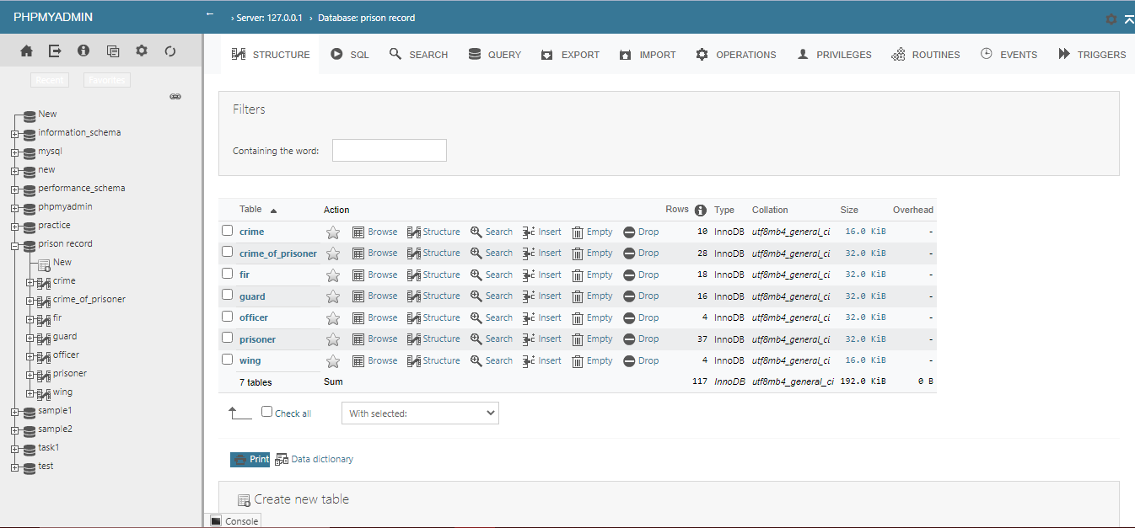

* Crime Table

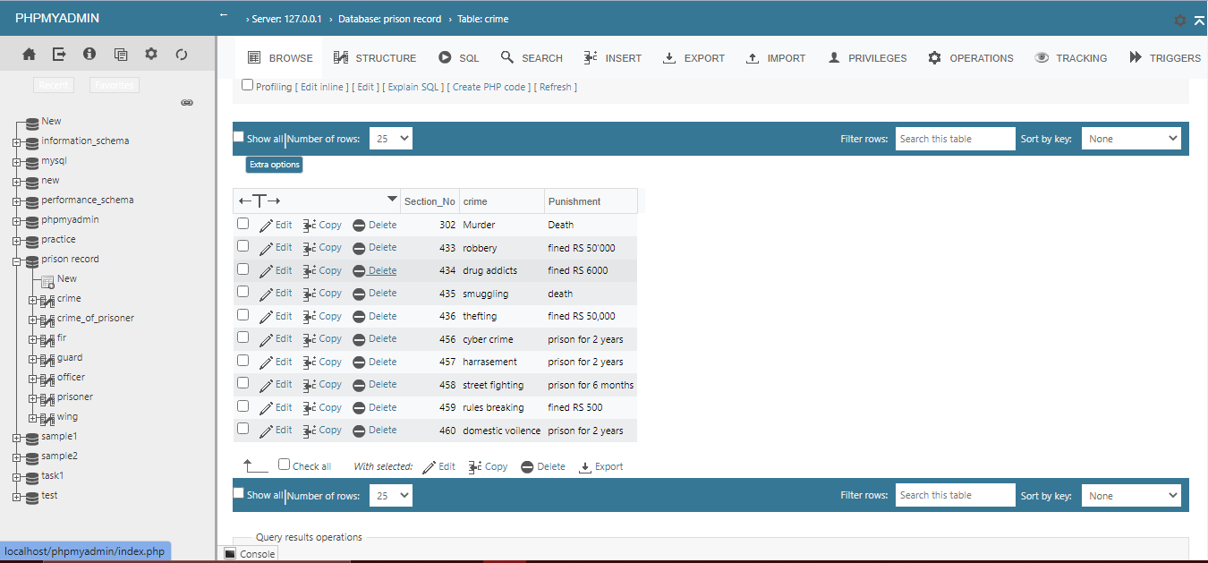

* Crime_of_prisoner Table

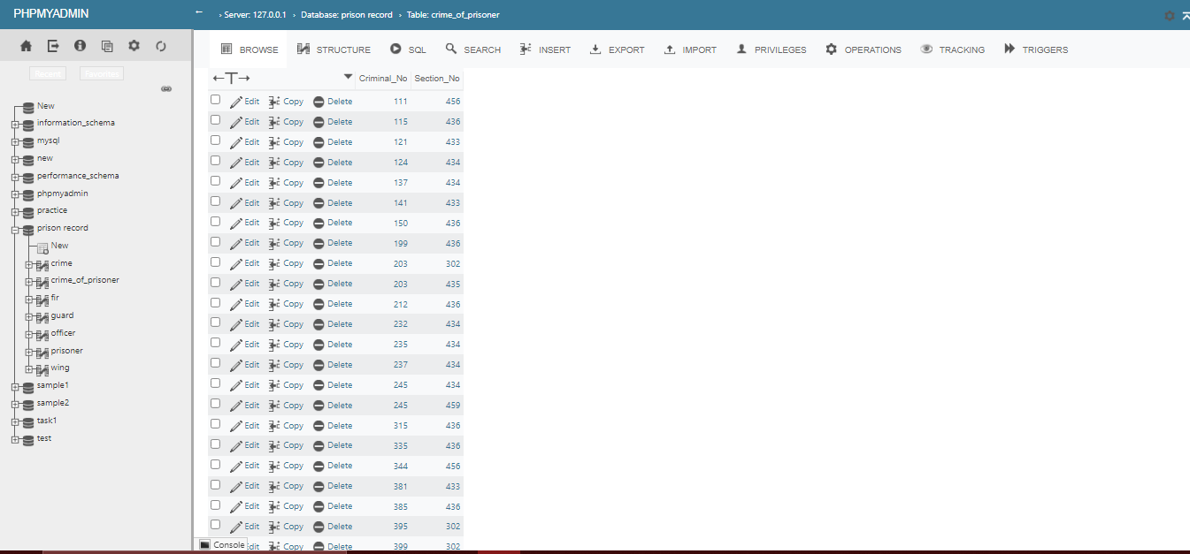

* Fir

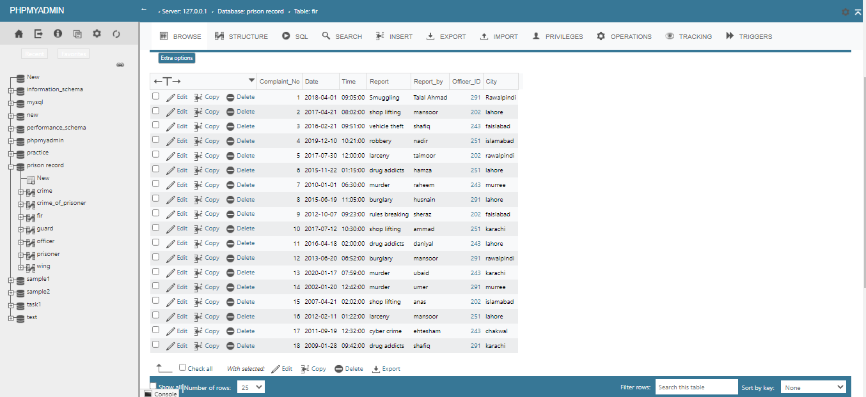

* Guard Table

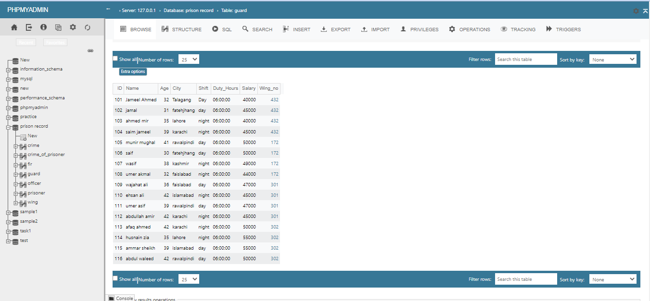

* Officer Table

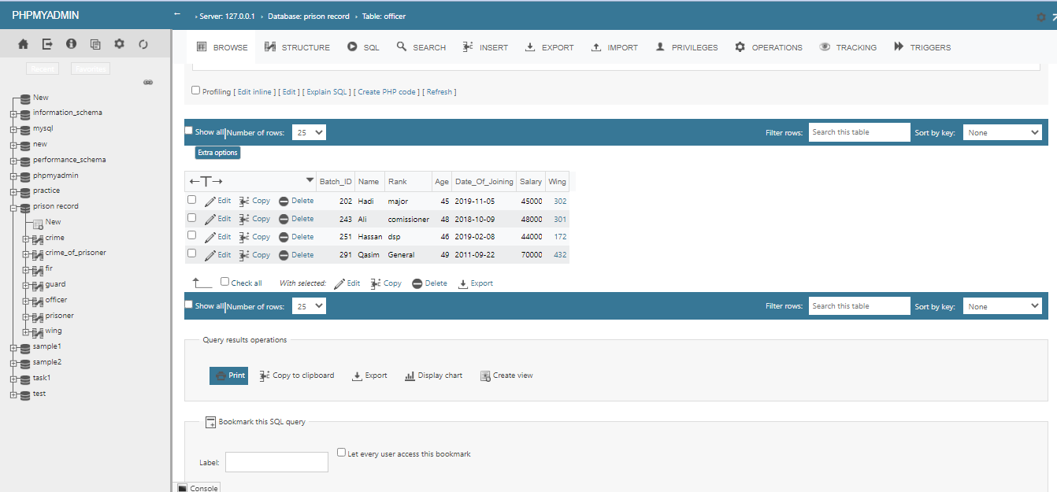

* Prisoner Table

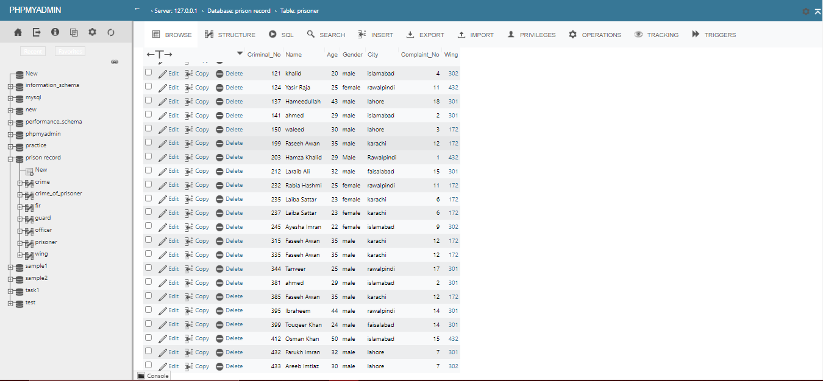

* Wing

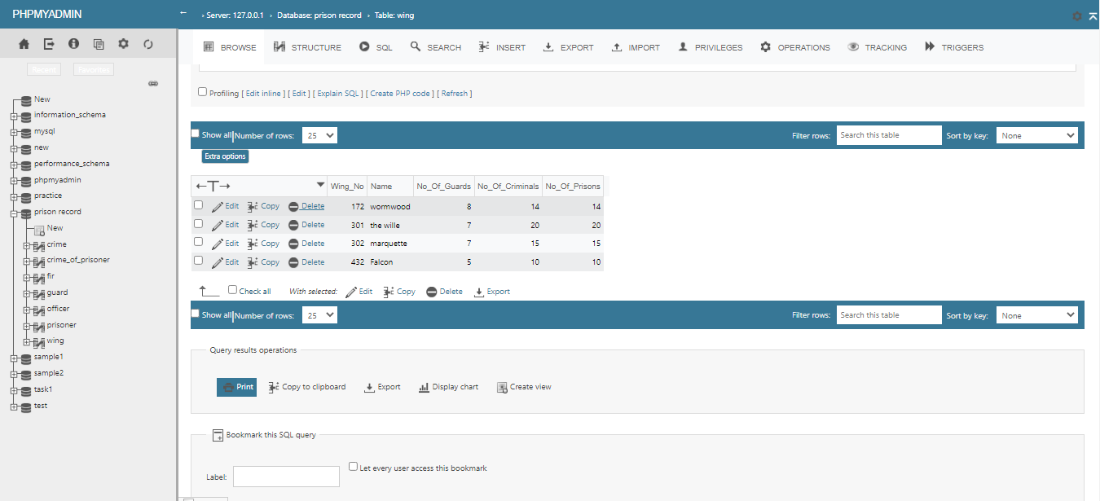

----THE END----